## **Abstract**

*The increasing number of cars in cities can cause a high volume of traffic and implies that traffic violations become more critical nowadays in the world and also around the world. This causes severe destruction of property and more accidents that may endanger people’s lives. To solve the alarming problem and prevent such unfathomable consequences, traffic violation detection systems are needed. The system enforces proper traffic regulations at all times and apprehends those who do not comply. A traffic violation detection system must be realized in real-time as the authorities track the roads all the time. Hence, traffic enforcers will not only be at ease in implementing safe roads accurately but also efficiently; as the traffic detection system detects violations faster than humans. This system can detect traffic light violations in real-time. A user-friendly graphical interface is associated with the system to make it simple for the user to operate the system, monitor traffic, and take action against the violations of traffic rules.*

***Key Words:***Arduino, speed violation, signal jump, traffic violation, PIR sensor, passive infrared sensor.

# TABLE OF CONTENTS

|  |  |  |
| --- | --- | --- |
| **Chapter No.** | **Title** | **Page No.** |
| 1 | INTRODUCTION | 1 |
| 1.1 | Introduction | 1 |
| 1.2 | Problem Statement | 1 |
| 1.3 | Aim and Objectives | 2 |
| 1.4 | Advantages | 2 |
| 1.5 | Disadvantages | 2 |
| 1.6 | Applications | 3 |
| 2 | LITERATURE SURVEYED | 4 |
| 3 | PROJECT DESIGN AND IMPLEMENTATION | 5 |
| 4 | REQUIREMENTS | 6 |
| 4.1 | Hardware Requirements | 6 |
| 4.2 | Software Requirements | 6 |
| 5 | RESULTS | 7 |
| 5.2 | Result | 7 |
| 5.2 | Project Snapshots | 8 |
| 6 | CONCLUSIONS | 9 |
| 7 | FUTURE SCOPE | 10 |
| 8 | REFERENCES | 11 |

vi

**LIST OF FIGURES**

|  |  |  |
| --- | --- | --- |
| **Sr. No** | **Name of Figure** | **Page. No** |
| 3.1 | Circuit Diagram | 5 |
| 3.2 | Block Diagram | 5 |
| 5.1 | Result | 7 |
| 5.2.1 | Code 1 | 8 |
| 5.2.2 | Code 2 | 8 |

vii

## **1. INTRODUCTION**

#### **Introduction**

Traffic violation detection systems are being developed as the number of vehicles on the road is increasing at a large rate. This increase in number makes it difficult for trigger base traffic violation detection system to keep up with the high volume of traffic and it is not designed to detect multiple traffic violation at the same time for a given vehicle as a result for an increase in traffic rule violation due to the lack of advance detection. The traffic rule violation leads to various road accidents, traffic administration poses numerous basic difficulties in most present-day urban areas. Manual checking of vehicles is troublesome, and mistake-inclined due to feeble and problematic human memory.

Consequently, a need arises for a traffic violation detection system to deal with this errand, which can identify criminal traffic offenses, for example, signal jump, over speeding and vehicle count. The first traffic monitoring began with human traffic cops assigned at every junction to monitor traffic, which required human resources and presence at all times. This consequently became difficult with the increase in vehicles. This gave way to trigger based traffic detection systems, which were specialized systems meant for detecting one type of violation – speed. These were costly, could only be placed at one point on the road, and were easy to avoid.

A new system was required that could be operational 24x7, with least or no human resource requirement and which could identify multiple violations with high accuracy. This is how traffic violation detection using Force Sensor came into being. Traffic violation detection using force sensor is mainly based on force applied by the body, which can alert the present officers and change the sign automatically. The PIR sensor will detect the motion of the body i.e. from where the car is running into the system and will change the signal red in the mountainous regions. It will also inform the on-duty police officer about the same and save the concerned parties and prevent the mishap from happening.

Traffic Detection system, the proposed architecture of surveillance system with intelligent detection and tracking of multiple vehicles from the surveillance input video using the PIR sensor as a motion detection algorithm. This is done through a neural network and an object detection model which are used in the classification of the moving objects into different respective classes, thus achieving vehicle classification. Next, from the same given video footage, traffic lights, zebra crossing, different lanes, and traffic signs are classified this comes under environment awareness. Combining these two, now violations are detected based on violations are then detected these can occur on the road which are signal jump, speed detection, and vehicle count.

The main objective is to detect multiple vehicle violation detection and it gives a more detailed picture of concepts and technology involved in creating a traffic violation detection system using computer vision. It also aims to throw light on some of the applications and the latest developments being made in the said field.

* 1. **Problem Statement**

Traffic congestion problems are seen in metropolitan cities especially in downtown areas. One of the major reasons behind this breaking of traffic signals and accidents caused by it. Monitoring of traffic violators will not only reduce such accidents but also decrease the chaos created by breaking of traffic signals.

* 1. **Aims and Objectives**

**Aim**:

To implement TRAFFIC MANAGEMENT SYSTEM by taking into account the increase in violation.

**Objectives:**

Our proposed system has the following objectives to serve:

1. To minimize the violence of traffic rules
2. Reduce casualties
3. Better and efficient results
4. Cost effective
   1. **Advantages**

* It can be used to prevent accidents and mishaps.
* It helps in reducing traffic in single lane roads.
* It can alert the driver coming from the opposite lane.
  1. **Disadvantages**
* It requires constant power supply to work
* Its installation is difficult.
* If the circuit is break, it won’t work
* The maintenance of the system is high and costly.
  1. **Applications**

It could be used at every traffic signals where the traffic congestion is more or it is a single lane road. This system can be easily adapted at hilly or mountainous region.

* 1. **LITERATURE SURVEY**

|  |  |  |  |  |
| --- | --- | --- | --- | --- |
| Sr. No | Title | Author | Publication | Approach |
| 1. | An Internet of Things (IoT) based Smart Traffic Management System | Abdul Kadar Muhammad Masum  Md. Kalim Amzad Chy  Iaamanur Rahman  Mohammad Nazim Uddin  Khairul Islam Azam | IEEE | This paper proposes a real-time traffic management system (TMS) using the Internet of Things (IoT) and data analytics |
| 2. | A Low-Cost IoT Application for the Urban Traffic of Vehicles | Hugo Nugra  Alejandra Abad  Walter Fuertes  Fernando Galarraga  Hernan Aules  Cesar Villacis  Theofilos Toulkeridis | IEEE | To implement a low-cost Internet of Thing proposal, in order to monitor and analyze traffic circulation and provide solutions to reduce the negative effects caused by traffic congestion |
| 3. | Advanced Traffic Violation Control and Penalty System using IoT and Image Processing Techniques | Shreya Asoba  Shreya Supekar  Tushar Tonde  Juned A. Siddiqui | IEEE | This paper highlights the monitoring of traffic signal violation and its penalty system. |

1. **PRODUCT DESIGN AND IMPLEMENTATION**
   1. **Circuit Diagram**

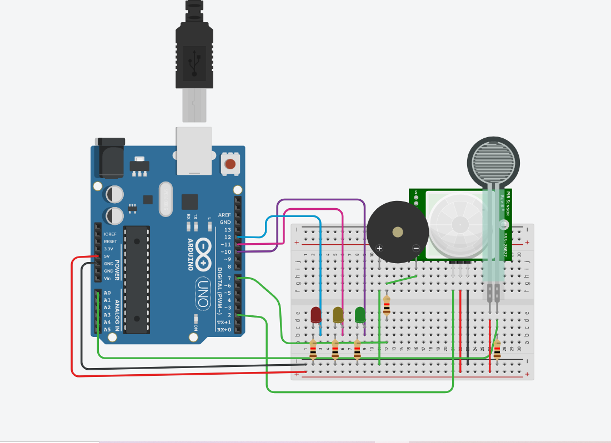

* 1. **Block Diagram/ Architecture**

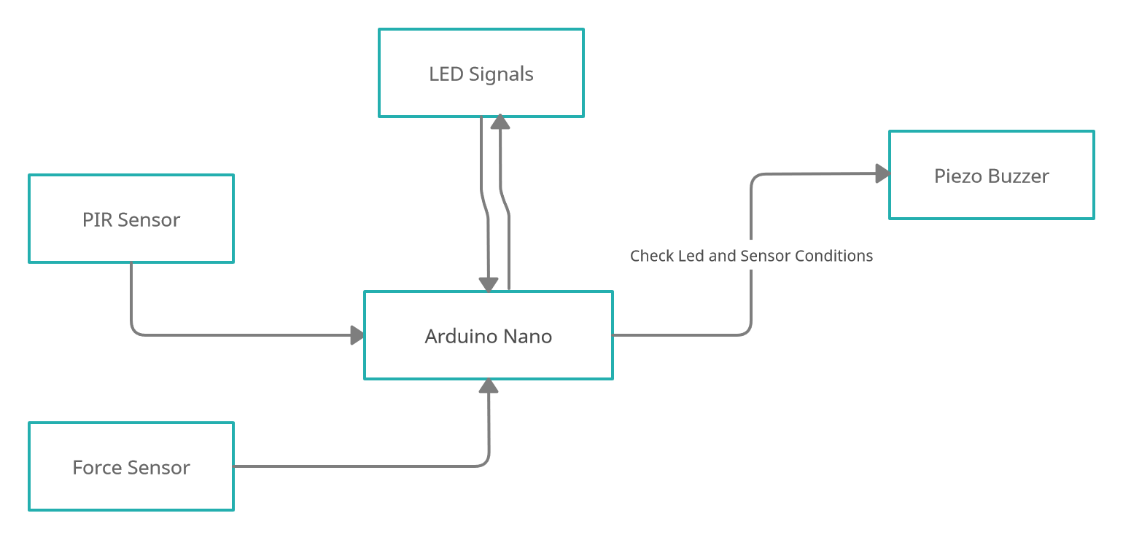

1. **REQUIREMENTS**
   1. **Hardware Requirements**

* Arduino Nano
* PIR Sensor
* Force Sensor/Piezo Sensor
* Piezo Buzzer
* LED
* Resistors
  1. **Software Requirements**
* Arduino IDE

1. **RESULTS**
   1. **Results**

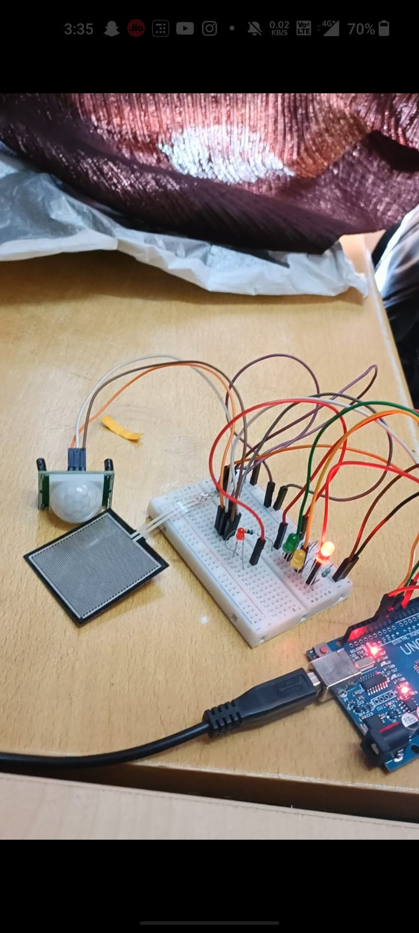

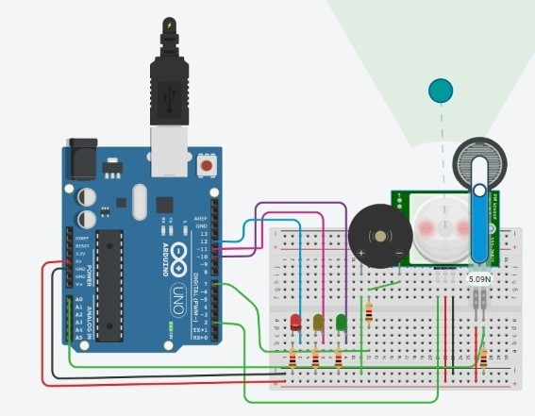

* 1. **Project Snaps**

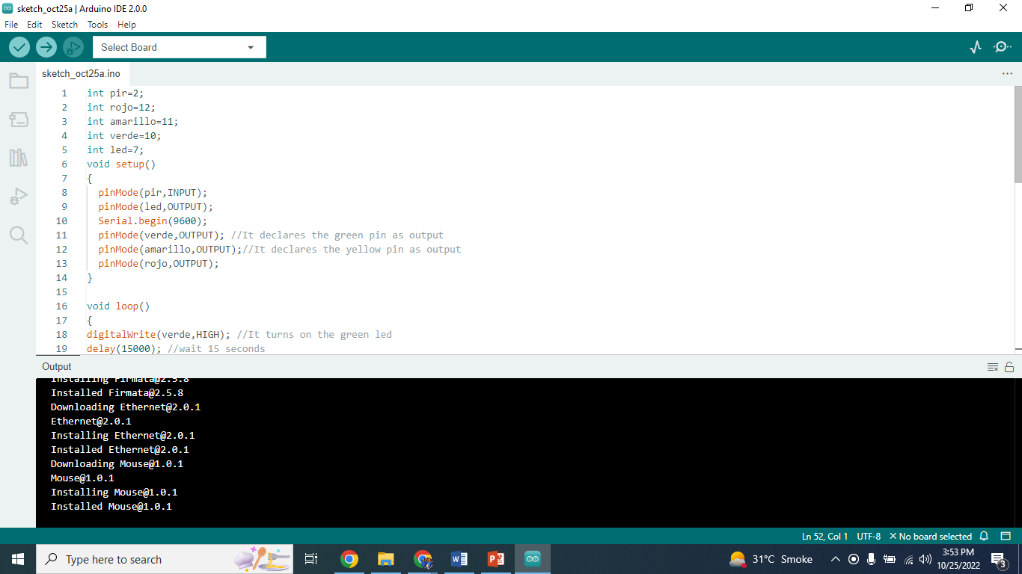

**6 CONCLUSION**

The system helps to stop and control the violation of traffic rules i.e. crossing the red signal which leads to many road accidents. This, also would alert the traffic police at the signals with help of the buzzer sound. In near future, this will also capture the pictures of the violating vehicles. This would definitely create a sense of awareness among the drivers and they will be more alert while on the day.

Detections of traffic violation in the video surveillance is challenging as the number of vehicles on the road and traffic rules are depended on the different area of the road and timings. This paper proposes that the YOLOv3 algorithm is suitable for traffic violation detection. Results show that the detection of multiple traffic violations from a single input source is achievable. The system has an accuracy of 97.67% for vehicle count detection and an accuracy of 89.24% to detect the vehicle speed. The detection time is lower for high dense traffic flow. Thus, the system operation speed is dependent on the density of traffic.

1. **FUTURE SCOPE**

With the increasing growth in traffic density all over the world, it possesses a great challenge to traffic management. Emphasis should be that large area is covered and the high volume of traffic monitoring and detection from a single input source using parallel computation.

The Following Features can be added to the proposed system in the future:

* Capturing the picture of the vehicles violating the traffic rules
* Using image processing on the captured photographs send the car details to Government officials.

1. **REFERENCES**

* H. Nugra et al., "A Low-Cost IoT Application for the Urban Traffic of Vehicles, Based on Wireless Sensors Using GSM Technology," 2016 IEEE/ACM 20th International Symposium on Distributed Simulation and Real Time Applications (DS-RT), 2016, pp. 161-169, doi: 10.1109/DS-RT.2016.24.
* Kadar Muhammad Masum, M. Kalim Amzad Chy, I. Rahman, M. Nazim Uddin and K. Islam Azam, "An Internet of Things (IoT) based Smart Traffic Management System: A Context of Bangladesh," 2018 International Conference on Innovations in Science, Engineering and Technology (ICISET), 2018, pp. 418-422, doi: 10.1109/ICISET.2018.8745611.
* S. Asoba, S. Supekar, T. Tonde and J. A. Siddiqui, "Advanced Traffic Violation Control and Penalty System using IoT and Image Processing Techniques," 2020 2nd International Conference on Innovative Mechanisms for Industry Applications (ICIMIA), 2020, pp. 554-558, doi: 10.1109/ICIMIA48430.2020.9074949.